Purpose
The following document should be used as a guideline for school districts to provide quality agricultural education programs and appropriate use of extended programming. The guidelines are policy recommendations from the Ohio Department of Education (ODE), Office of Career-Technical Education and are not mandatory.

In addition, this resource is intended to aid in documenting the value of an agricultural education program. It will provide an effective way to communicate evidence to influential partners and community members that have a direct interest in an agricultural education program. All agricultural education programs should have an improvement plan in place that is based on Ohio’s Quality Program Standards for Career-Technical Education Programs.
Understand why an agricultural education program exists today
The Smith-Hughes Act of 1917 formally established agricultural education as a means of preparing young people for careers in agriculture. Over the years, the number of students served has grown and the types of agricultural education programs have evolved to meet the ever-changing global economy.
The three-component structure of Agricultural Education prepares students for successful careers and a lifetime of informed choices in global agriculture, food, fiber, and natural resources systems.
- Engage students through high-quality instruction and learning through interactive classroom and laboratory experiences.
- Develop premier leadership, personal growth and career success through participation in FFA programs and activities.
- Build work-readiness skills through experiential learning in supervised agricultural experience programs.
Install an active industry-based advisory committee
The advisory committee can be an effective resource in strengthening an agricultural education program. Per Ohio Administrative Code, advisory committees are required for workforce development programs such as agricultural education programs. A program advisory committee makes recommendations on program design and program improvement. It should be comprised of business and community members who, because of their work on the advisory committee, will know more about the program than anyone else and should be able to support and document the strengths of the program.

An advisory committee should include business and industry representatives, school administrators, and local supporters of the agricultural education program. Responsibilities of the advisory committee include:
- Review all features of the program including goals, facilities and curriculum.
- Identify industry trends related to employee knowledge and skills, technology development, and business economic patterns.
- Assist in identifying places for internships and cooperative work placement.
- Encourage cooperation, communication, and a better understanding of agricultural education programs among employers, students, and the public.
- Serve as a communication link within the community.

Enhance community engagement
Maintaining closer communications between the school and the community can be strengthened by developing a close relationship with the local FFA alumni affiliate and/or an adult agricultural education program such as the Ohio Farm Bureau Young Agricultural Professionals (YAP). Promoting your school district through these types of organizations can generate greater support for the agriculture education program and district by increasing community ownership and involvement in the program. While alumni and young professionals can help enhance the personal development aspect of FFA by serving as mentors, coaches, employers, and extra hands for the teacher, it is important to remember that the organizations cannot replace an advisory committee and should not be used in the same manner.

Career Technical Education Funding in Ohio
Additional funding may be available for Ag. Education. It is important to be aware of how CTE funding works in Ohio. CTE funding received by a school district must be spent on allowable expenses within a CTE program. By staying current with state CTE funding information and current policy, a school district will have the knowledge to accurately budget and approve acceptable expenditures for CTE programs.

Please contact your Ohio Department of Education Administrative Field Services Program Consultant for further information click here to find your consultant.

Quality agricultural education programs
ODE has identified 10 common standards for agricultural education programs to guide and facilitate program improvement. They were developed from research with stakeholders, consultation with education support agencies, and examination of model quality program standards from other states. There are quality indicators for each of the 10 standards and criteria for each quality indicator. The result of this work is a rubric designed to assist in the examination of the total agricultural education program and serves as the basis for continuous program improvement.

Ohio’s Quality Program Standards serve as a tool for career-technical planning districts (CTPDs) and the Office of Career-Technical Education at ODE in the annual review of career-technical education programs as required in state law. Teachers can use quality program standards to drive innovation, support different learning styles, adapt and respond to changes in technology, and prepare all students for career success. In addition, quality program standards provide an effective way to communicate evidence to stakeholders who have an interest in agricultural education. All agricultural education programs should have a continuous growth plan to increase progress identified in the quality program standards document.

While there are many facets of an agricultural education program that could be considered, the following 10 elements position the program to play a key part in the success of a school district’s mission.
Quality Program Standards
Standard 1: Instructional Facilities and Resources
The facility supports implementation of the career-technical program and provides students with opportunities for the development and application of technical knowledge and skills.
Standard 2: School and Community Relations
School, community, and industry partners are engaged in developing and supporting the career-technical education program.
Standard 3: Program Planning and Evaluation
A results-driven needs assessment and evaluation exists for continual program development and improvement.
Standard 4: Quality Educators that Contribute to the Profession
Career-Technical educators continuously develop as professionals and support the growth of the profession they serve.
Standard 5: Curriculum and Program Design
The career-technical education program includes foundational and specialized courses designed to prepare students for lifelong learning within a career pathway.
Standard #6: Instruction
Career-Technical Education programs promote high academic achievement, technical knowledge and skill development of all students.
Standard #7: Assessment
Career-Technical education programs use authentic and performance-based assessments to measure student learning and skill attainment of Ohio’s Career Field Technical content standards.
Standard #8: Experiential Learning Experience Programs
All students participate in an experiential learning program that connects the technical knowledge and skills learned in both classroom and laboratory to the work place.
Standard #9: Leadership Development/CTSO
All students participate in intra-curricular Career-Technical Student Organization (CTSO) that promotes cognitive knowledge and skill and leadership development.
Standard #10: Student Access
Career-technical education programs serve all students interested in preparing for a career in any of Ohio’s 16 Career Fields and are reflective of the school’s student population. Capacity should permit students to schedule first choices of career area.

Guidelines for appropriate use of extended programming
Purpose of Extended Programming
Extended programming provides career-technical education teachers opportunities to increase student learning outside of the school day. Extended programming can occur after school hours, on weekends, during holidays, and during summer months. Extended program time does not include regular school contract hours or hours reasonably expected of teachers not receiving extended program time. For example, a teacher should not count the time spent attending an in-service meeting that occurs because of early dismissal for the students as extended program time. The following are factors to consider when determining appropriate extended programming time.

Acceptable Uses of Extended Programming
- Individualized instruction and supervision related to the student’s career pathway;
- Group instruction and supervision;
- Teacher professional development activities beyond those required by the district related to the professional discipline;
- Industry linkages designed to garner program support and to develop work-based learning opportunities;
- Community linkages designed to garner program support; and
- Engagement in student activities related to the program’s course of study and the local career-technical student organization (CTSO) activities.
Determining Appropriate Amounts of Extended Programming
- School administrators should establish extended programming contracts and plans with teachers in advance of program operations. This is important so teachers and school administrators are clear on expectations.
- The amount of extended program time necessary depends on the individual program. The extended program plan should include educational activities that meet the program’s objectives, the students’ educational objectives, and the teacher’s professional growth objectives.
- School administration should take into consideration the program’s advisory committee and teacher recommendations in determining the amount of extended program time provided to a program.
Core Factors
The majority of extended program time should be spent on student instructional time, including student activities. Professional development, business, industry, and community linkages are also important areas in which teachers should be given extended program time.

Additional Factors
Limited student opportunity
Teachers serving students with limited opportunities or unique problems should have additional extended program time. Programs that serve students with limited natural experiential learning opportunities will require additional extended program time to provide these opportunities.

-New programs
Teachers starting new programs may need additional extended program time during the first year of operation to properly implement and build the foundation of a quality program. This includes the establishment of the three-circle program model: sound classroom practices, innovative Supervised Agricultural Experiences (SAEs), and quality FFA engagement.

-Local priorities and traditions
Some communities have grown accustomed to certain activities being provided an agricultural educator. These include assistance with student learning activities at county fairs, participation in various Career Development Events (CDEs), and attending the State and National FFA Conventions and Ohio FFA functions provided by state leadership. Additional extended program time for these functions is appropriate to assure continued community satisfaction.

Assuring extended program accountability
Quality extended program accountability begins with written documentation between the teacher and the school. This documentation should contain the performance objectives to be achieved during the extended programming and the accountability documents to be used to verify accomplishment of the objectives. The teacher and school administrator should cooperatively develop the accountability documents to be used.

Recommended accountability documents include:
- Student competency attainment records such as student portfolios, student organization successes, or job placement. Individual visit result forms are also recommended;
- Accomplishment of Individual Professional Development Plan objectives by the teacher;
- Quality indicators for career-technical programs (e.g., Quality Program Review); and
- Mileage and visitation report forms.
Recommended elements of extended programming
- Instruction and supervision directly related to students’ experiential learning opportunities (e.g., co-op, internship, placement): 45% of extended time
- Engagement in CTSO events: 22% of extended time
- Curriculum-based skill activities: 11% of extended time
- Business, industry and community linkages: 11% of extended time
- Professional development: 11% of extended time
Experiential learning activities require the investment of resources such as time and money beyond scheduled class time. The Agricultural Experience Tracker (The AET) allows students to record these investments in experiential learning activities and provides a platform to assess the value of these investments in agricultural education programs.

Recommend Elements of Quality Extended Programing | Quality Indicator | Effective Percentage Time | Recommended Activities
Supervised Agricultural Experience Programs (Standard 8) | - All students have Supervised Agricultural Experience (SAE) programs based on career pathways and Ohio’s Career Field Technical content standards.  - SAE programs provide opportunities for students to master technical and critical thinking skills.  - Instructor maintains accurate and comprehensive records of all on-site instruction and supervision.  - Each student keeps up-to-date and accurate SAE records.  - Students have comprehensive SAE programs that are evaluated and assessed on knowledge, technical skill and growth. | 45% | - Individual SAE instruction is aligned with technical knowledge and skills.  - Student instruction at school facility learning venues (e.g. school farm, greenhouse, and land lab)  - Processing and evaluating student records  - Compilation and review of student award applications
Engagement in the FFA Organization (Standard 9) | - All students have full access to FFA membership and activities.  - Leadership activities are infused in instruction.  - The clear purpose of involvement is to develop and/or enhance citizenship, leadership and interpersonal skills.  - Student-led experiences integrated into activities. | 22% | - State and National FFA conventions  - Leadership and citizenship development programs (e.g., FFA Camp, Washington Leadership Conference)  - Implementation of chapter’s Program of Activities  - FFA chapter activities (meetings, banquet, officer retreat)  - District and state evaluations
Curriculum Based Skilled Activities  (Standard 6 & 7) | - Students demonstrate technical and academic performance through authentic assessments.  - Students demonstrate performance of skilled and technical competence in FFA competitive career development events. | 11% | - Provide authentic assessment opportunities aligned with local program of study for students through career development events.  - Provide opportunities for students to participate in appropriate sub-district, district, state and national career development events based on local program of study
Business, Industry and Community Connections (Standard 2 & 3) | - Relationships are built with business, industry and community stakeholders.  - Input from industry/community stakeholders is the basis for the design of program and curriculum  - Advisory committee assists with all aspects of the career- technical education program. | 11% | - Advisory committee meetings  - County/State fair responsibilities  - Industry-related education trips
Professional Development  (Standard 4) | - Instructor continues professional growth through content specific workshops.  - Instructor is an active member in related local, state and national professional education/industry associations. | 11% | - Technical update meetings (e.g. Ag Ed Summer Conference, pathway specific workshops)  - Professional Organizations (e.g. OAAE, ACTE)  - Ohio ACTE Conference  - OAAE/ODE Fall and Spring Meetings  - Washington Leadership Conference Advisor Program

2017 Program Demographics and Statistics to Support Experiential Learning
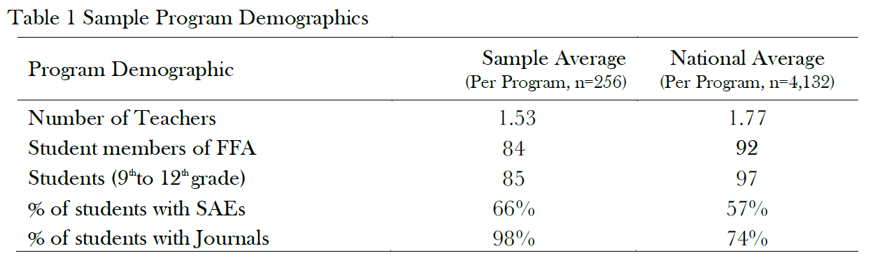
The table above indicates that 66% of students are documenting Supervised Agricultural Experience (SAE) involvement, which is an increase from 58% in 2016. In addition, 98% of students are documenting their time in experiential learning experiences. This data shows that 2017 represents a significant increase in SAE documentation and possibly SAE experiences of agricultural education students.
The results in Table 1 illustrate that the average Ohio program in this sample has one teacher, 85 students and 84 FFA members. The numbers of Ohio agricultural education students, teachers and FFA members are slightly less than the national averages in terms of but Ohio programs are higher in engagement in SAEs (66% compared to 57% nationally) and journal activities (98% compared to 74% nationally) and serve as the basis for this research.
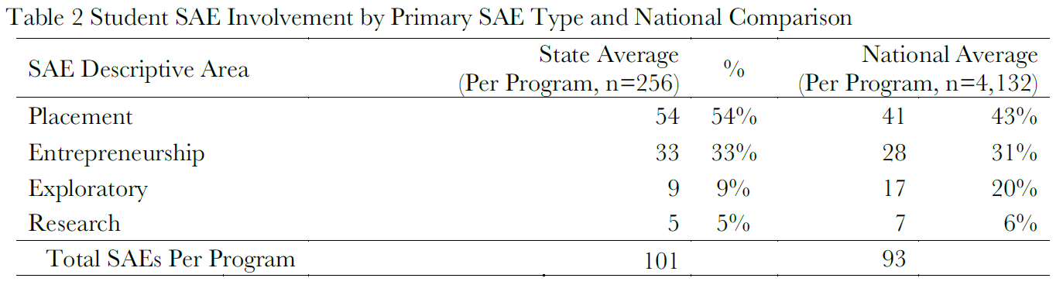
Ohio programs report greater engagement in SAE projects that are above the national 2017 results and are increases from 2016 state values. Ohio programs, on average, have 101 SAEs from 85 students, which is an excellent ratio of 1.19 projects per student in ag education (101/85). As students create their SAE projects, they define the SAE project area (AFNR aligned). Also, students track skill involvement by recording journal entries, also aligned to AFNR content standards. A summary of how SAEs align to the national AFNR content standards is illustrated in Table 3.

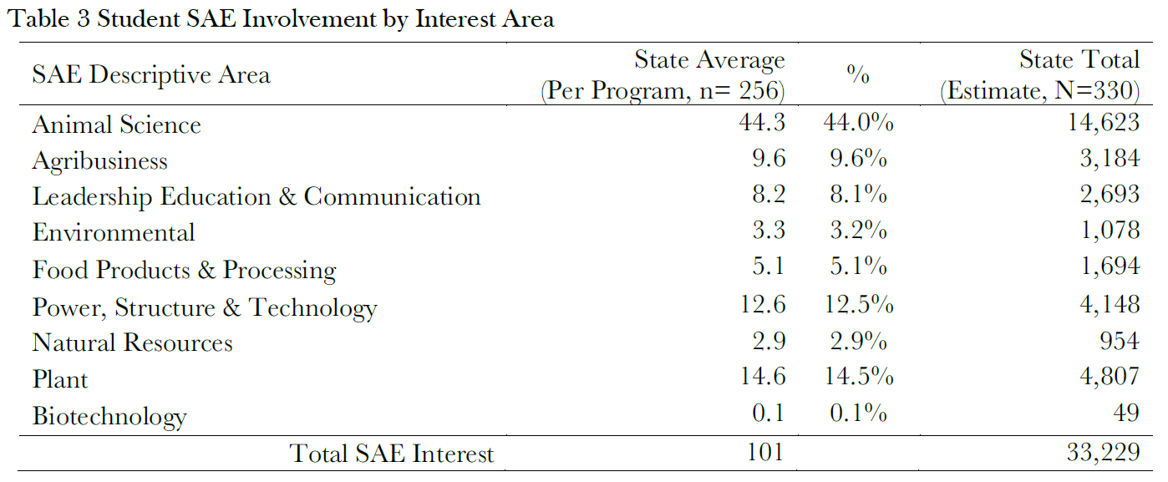
A large area of SAE involvement (44%) is in animal related projects, which is also the highest national area of involvement. In terms of state estimates, SAEs in Ohio programs manage 33,229 SAE projects, which is an increase to total SAE projects from 2016 (29,427). Other SAE areas of involvement are listed in table 3.
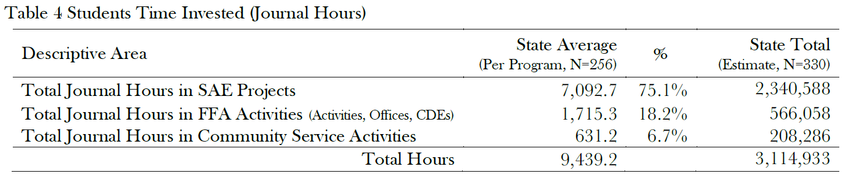
Student experiential learning experiences involve the investment of time (hours), which is a core area of record keeping. Experiential learning is shown in the above table with SAE, FFA, and community service activities.
As shown in Table 4, the largest investment of time is in SAE projects (75%), followed by FFA activities (18%) and community service (7%). In comparison to the 2016 report, programs show an 16% increase in documenting SAE experiences (7,092 hrs. compared to 6,109 hrs. in 2016), 11% increase in community service records (631 hrs. compared to 567 in 2016), and 8% increase in FFA activities (1,715 hrs. compared to 1,590 hrs. in 2016). According to a national measurement of volunteerism (https://www.independentsector.org), Ohio volunteerism value is $24.14 per hour. Using that per hour rate, volunteerism in agricultural education has an economic value of $5 million to the Ohio economy (208,286 x $24.14).

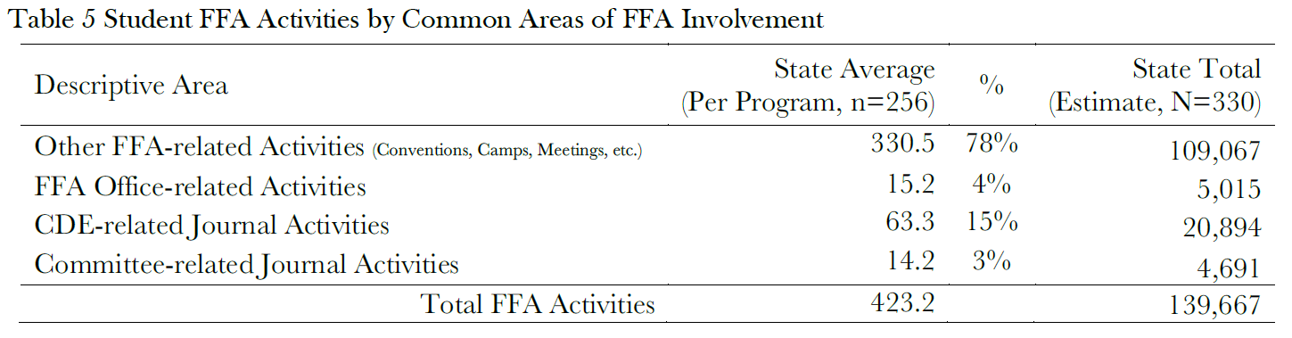

FFA involvement represents a range of different activities, which may include FFA conventions/camps/meetings, CDEs, FFA offices/leadership, and Program of Activities (POA) committee involvement. 2017 FFA activities are summarized in Table 5, which illustrates activities in FFA conventions/camps/meetings (78%) and CDEs (15%), with other areas listed in Table 5 and in total is an increase in involvement (139,667 activities compared to 121,942 in 2016).

2017 Economic Values from SAE
SAE engagement involves not only time and learning but also financial investments and returns. The next table provides a summary of students’ SAE earning by category for a typical agricultural education program.
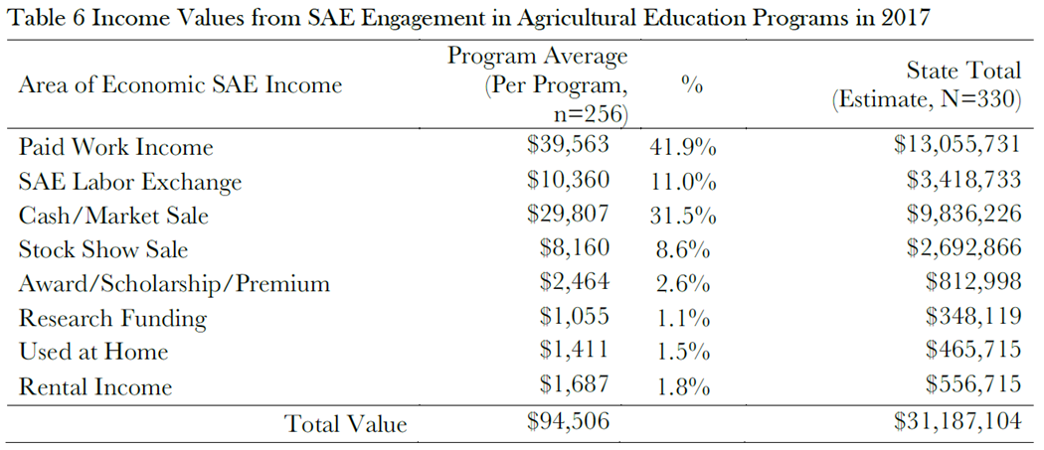
The 2017 value of $94,506 in SAE earnings per program exceeds the national SAE earnings average of $75,137. A core economic value of SAE projects is financial investments, such as operational expenses, which are the primary drivers of economic impact. Table 7 summarizes SAE investments in common areas of expenses.
The direct investment value of $50,738 per program and state estimate of $16.7 million in direct spending from SAE activities. Ohio SAE program investment values are slightly less than the national average of $54,609. These Ohio values are significant values that support the state’s economy and likely local economies from SAE activities.
Not only are SAE direct investments (operating expenses) valuable, but related non-current investment of SAE machinery, breeding animals, buildings and other items are additional SAE values that support the local and state economies. In 2017, SAE related non-current items averaged $12,302 in spending value per program. This brings total SAE-related direct spending to $63,080 per program in Ohio (SAE operations and SAE non-current items), which is illustrated in Table 8.
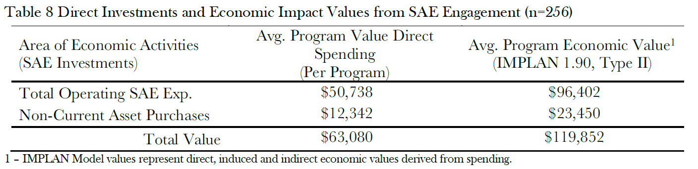
Direct spending is an important indicator, but additional impacts can be measured using economic multiplier factors ($1.90 per $1 in spending IMPLAN Type II Multiplier). In 2017, SAE spending (operations and noncurrent) created an economic impact value of $119,852 in local economies, which supports other job creation and values to other industries. Table 8 provides a summary of agricultural education program economic values (direct spending and economic value).

